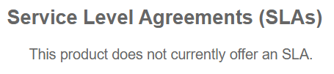

App & API Protector Hybrid
Client-Side Protection & Compliance
Firewall for AI
SIEM Integration
Unified Threat Shield
Noname Active Testing (“API Security SLA” under other Noname products?)
Noname Protect On-Prem (“API Security SLA” under other Noname products?)
DNS Posture Management (Same as for DNS or Edge DNS?)
Enterprise Threat Intelligence
PacketFence
Brand Protector
Compliance Management
API Gateway
EdgeKV
Adaptive Media Player
Akamai Video Manager (Powered By Cloudinary)
Akamai Visitor Prioritization (Powered By Queue-it)
API Prioritization Cloudlet
Application Load Balancer Cloudlet
Audience Segmentation Cloudlet
Cloud Wrapper
CloudTest
CloudTest On Demand
Edge Redirector Cloudlet
Enhanced Proxy Detection with GeoGuard
Forward Rewrite Cloudlet
Image and Video Manager - Image Optimization
Media Services Live 4
Media Services Live 5 (Powered By Harmonic)
NetStorage
OTA Updates
Phased Release Cloudlet
Request Control Cloudlet
Up to 4-Pack Cloudlets Bundle
Vaccine Edge
Vaccine Edge Waiting Room
Datastream 2.0
EdgeComputing ESI Usage
Edgescape Pro - Single Application
Edgescape Pro Enterprise
Edgescape Standard - Single Application
Edgescape Standard Enterprise
mPulse
TrafficPeak
Akamai 3rd party Transactable service(s)
Macrometa

