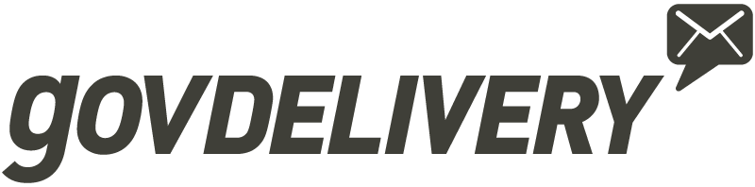

Public Sector Procurement Vehicles & Contracts

Carahsoft serves as the master government aggregator and distributor for GovDelivery. Through this partnership, we provide public sector organizations with easy access to GovDelivery’s proprietary network and secure cloud-based enterprise marketing platform which empowers agencies to reach, inform and engage audiences through web, email, mobile and social media channels.

Carahsoft offers expertise in government procurement processes and practices, and holds numerous
contracts that enable GovDelivery to sell to:
- State Agencies
- Cities, Counties, and Local Government
- School Districts (K-12, and charter/private schools)
- Higher Education Institutions (universities, community and private colleges,
and technical/vocational schools)
- Federal Government Agencies/Organizations
GovDelivery’s solutions are available through the contracts and purchasing agreements
highlighted below.

State and Local Government Contracts & Education Procurement Vehicles

Carahsoft holds state-, city-, county-, and technology-specific contracts that accelerate procurement for government agencies and educational institutions. In addition, through GSA’s Cooperative Purchasing Program, state, local, and tribal governments can purchase through specific GSA Schedule contracts.

Carahsoft also partners with resellers who focus on states and regions throughout the country.
Through these teaming arrangements, Carahsoft and GovDelivery have access to these vehicles as well.

GSA Cooperative Purchasing Program
Contract Number: GS-35F-0119Y
Term: December 20, 2011 – June 17, 2017

California Multiple Award Schedules (CMAS)
Contract Number: CMAS 3-12-70-2247E
Term: August 28, 2012 – March 31, 2017

Florida Commercial-Off-the-Shelf (COTS)
Contract Number: 43230000-14-01
Term: September 9, 2014 – September 8, 2018
(with 2 option years)

State of New Mexico General Services Department Contract
Contract Number: 30-000-13-00060
Term: March 18, 2013 – March 17, 2017

Ohio State Term Schedule
Contract Number: 534354
Term: February 10, 2012 – June 17, 2017

Texas Department of Information
Resources (DIR)
Contract Number: DIR-SDD-1917
Term: October 1, 2013 – January 1, 2017

State and Local Government Contracts & Education Procurement Vehicles (cont.)

Texas Department of Information
Resources (DIR)
Contract Number: DIR-TSO-3149
Term: June 22, 2015 – June 22, 2019
(with 3 option years)

Virginia: Fairfax County IT Hardware, Software, and Services
Contract Number: 4400006323
Term: October 4, 2015 – October 4, 2020
(with 5 option years)

Virginia Association of State College & University Purchasing Professionals (VASCUPP)
Contract Number: UVA1482501
Term: May 2, 2014 – June 17, 2017
Virginia Information Technology Agency (VITA) DPS
Contract Number: VA-140401-CARA
Term: April 1, 2014 – March 30, 2017
(with 2 option years)
Washington: City of Seattle
Contract Number: 0000003265
Term: July 11, 2014 – June 17, 2017

Cooperative Purchasing
Contracts for State/Local Government and Education

Cooperative purchasing contracts are available for use across state, local, and educational entities.

National Intergovernmental Purchasing Alliance (National IPA)
Contract Number: R150402
Term: June 1, 2015 - May 31, 2018
(with 2 option renewal years)

Federal Procurement Vehicles

GSA Schedule 70
Contract Number: GS-35F-0119Y
Term: December 20, 2011 – June 17, 2017
SEWP V
Group A Small: NNG15SC03B
Group D Other Than Small: NNG15SC27B
Term: May 1, 2015 – April 30, 2020
(with 5 option years)

Tiffany Goddard
Director of GovDelivery Sales
tiffany.goddard@carahsoft.com
703-871-8640

Ellen Lord
Director of Contracts
ellen.lord@carahsoft.com
703-871-8679

Jack Dixon
Contracts Specialist
jack.dixon@carahsoft.com
703-230-7545
ORDERING INFORMATION
Federal Taxpayer ID: 52-2189693
DUNS Number: 088365767
Shipping Point: FOB Destination
Terms: Net 30 on approved credit
contracts@carahsoft.com
888-66-CARAH (888-662-2724)

For More Information

